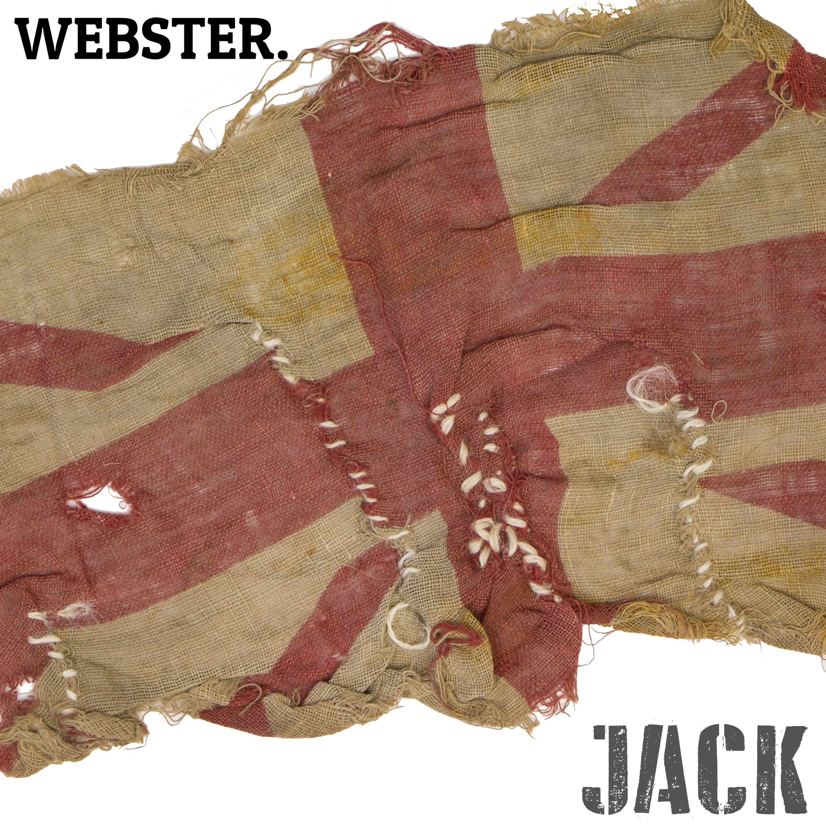
Webster releases, ‘Jack’, a song inspired by a remarkable, D-Day story.
‘Jack’ is released on 6th June 2019, coinciding with the 75th anniversary of the D-Day landings - one of the most history defining events of our modern age.
A remarkable, true and emotive story of a tank crew who befriended a local family near Portsmouth, UK where much of the landing force sailed from in 1944. The song ‘Jack’ is inspired by this incredible tale of a lost, then found, union flag. It was given to the troops by the family as a gift, prior to them embarking on one of the most important, history defining moments of World War Two.
On the eve of D-Day, this particular group of troops from the Grenadier Guards were amongst tens of thousands that lined the streets of England, before the crossing took place. The Whittle family invited the tank crew into their home for warm baths and meals. The family gave them a union flag, which was proudly flown on their tank, until just before VE day (nearly a year later). It was then lost during battle and the family (who were in touch with the crew via letters) sent a replacement flag.
Webster, a recent BBC Introducing featured artist, is a shape-shifting, genre-bending collective of vocalists, poets, collaborators and producers, led by musician and songwriter Ben Webster Williams.
Letters of friendship exchanged between the Whittle family and the tank crew from the Grenadier Guards, unbelievably, are preserved at the D-Day Story in Portsmouth along with the flags. Included in the collection is the original worn and faded flag, given by the family of Shirley Whittle (then aged four) before going over to Normandy in addition to the union flag, sent by the family as a replacement. Incredibly, the tank crew found the lost flag again when they returned to the same area, and was posted back to the Whittle family as a souvenir.
More recently, Seekers - a creative social enterprise based in Portsmouth were conducting some research at the D-Day Story in preparation for their forthcoming Seekers D-Day to VE Day Trail. Founder Clair Martin and her friend, Wing Chan, discovered the inspirational story and invited Webster to bring it to life through song.
The story sparked the imagination of Webster, who lured in some fine music collaborators to bring his composition to life, including the stirring trumpet talents of Bobby Blencowe, a member of the esteemed, Band of the Coldstream Guards (one of the oldest and best known bands in the British Army, having been officially formed in the 1700’s).
Musicians featured include: Ben ‘Webster’ Williams (Lead Vocals, Rhythm Piano & Ukulele), Bobby Blencowe (Trumpet), Sam Neild (French Horn), Barney Green (Lead Piano and Accordion), James Mason (Bass), Josh Wills (Drums), Liz Arcane (Backing Vocals), Jim Sole (Backing Vocals) & Chezelle Wilson-Williams (Backing Vocals). Recorded, Mixed & Mastered at Island Farm Studios. Produced by James Mason & Webster.

Notes to Editors:
- Webster releases ‘Jack’ on D-Day, 6th June 2019, worldwide through all major music download and streaming platforms.
- Shirley Whittle, who was aged four at the time of the D-Day landings, still resides locally near Portsmouth.
- The two flags and a collection of letters are preserved at the D-Day Story, Portsmouth, UK.
- With their HQ based in Gunwharf Academy Portsmouth, UK, Seekers - are a creative social enterprise that develop a range of creative activities, which act as a platform to link young people from their local communities to engage with the history, heritage and culture around them through art, music and technology.
- Seekers have been awarded a grant from the National Lottery Heritage Fund to deliver their community project “Follow Shirley’s Flag from D-Day to VE Day 75th Anniversary”
- A percentage of the profits from the sale of the single will go to support the invaluable work of Seekers Social Enterprize
- The City of Portsmouth is set as a focal point of the UK commemorations, hosting the national events across four days to mark the 75th anniversary of the D-Day landings.
For further information regarding the ‘Jack’ song release contact:
Webster HQ: ben@webstermusic.co.uk
Seekers (Clair Martin): seekerscreate@gmail.co.uk

Full EPK (including High Res images): www.webstermusic.co.uk/epk

